Business Intelligence
Professor: Antoine Dinimant

Group: Hunter X Hunter
- Shyamal Deepak VEMPADAPU
- Sarvan CHATTU
- Venkatesh LANKALAPALLI
- Trinath GURRAPUSALA
- Suraj Reddy JAGIRAPU

IMDb Official Movie Data
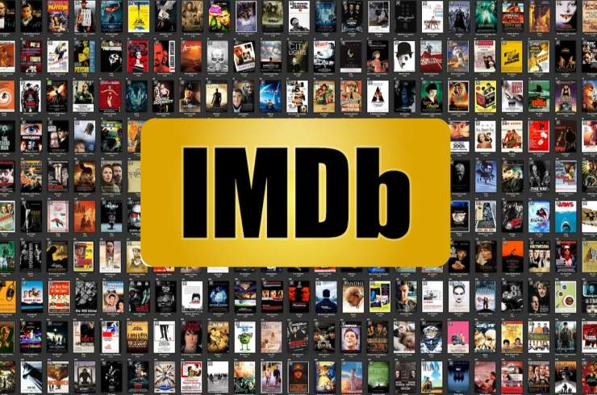

Dataset: https://datasets.imdbws.com
The data contains the following columns:
- Tconst
- Movie_Tiltle
- Release_Year
- Genre
- Average_rating
- Number_of_Votes

Theme:
This study analyses IMDb movie ratings and audience popularity to understand how they vary across different movie genres and release years. The analysis helps identify trends in viewer preferences, highly rated genres, and changes in audience interest over time.
Data Dictionary:

FIELD | DESCRIPTION | TYPE | ROLE
TCONST | Unique movie identifier | Text | Dimension
MOVIE_TITLE | Title of the movie | Text | Dimension
RELEASE_YEAR | Year the movie was released | Integer | Dimension
GENRE | Genre of the movie | Text | Dimension
AVERAGE_RATING | Average IMDb user rating | Decimal | Measure
NUMBER_OF_VOTES | Total number of user votes | Integer | Measure

Snowflake Schema:

